Base de datos
Alumnos: Nicolas Stchigel, Benjamin Ricci
- SET NULL:
  - DELETE:
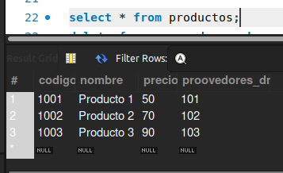
delete from proovedores where dni=101;
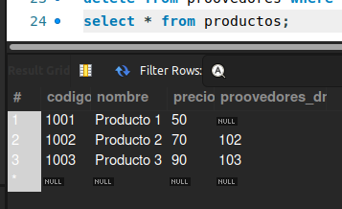
  - UPDATE:
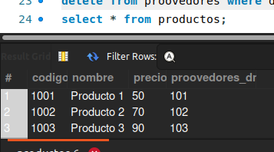
update proovedores set dni = 104 where dni=101;
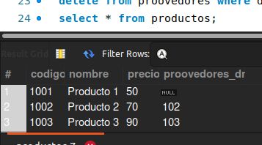
- CASCADE:
  - DELETE:
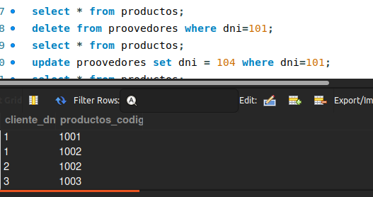
delete from productos where codigo = 1001;
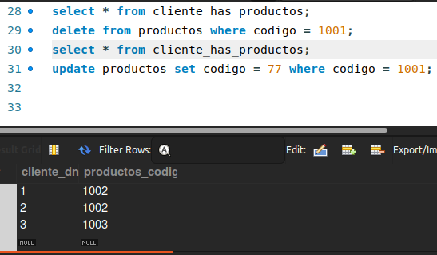
  - UPDATE:
update productos set codigo = 77 where codigo = 1001;
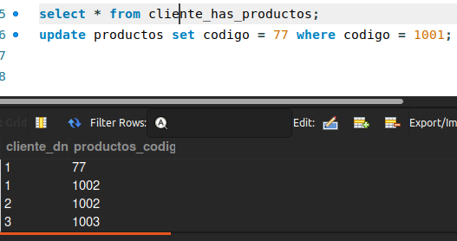
- RESTRICT:
  - DELETE:
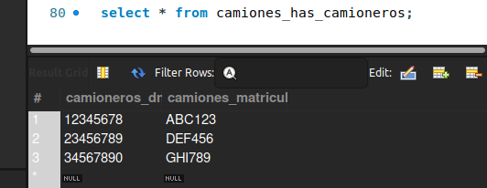
delete from camiones where matricula="ABC123";
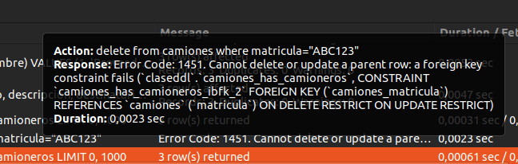
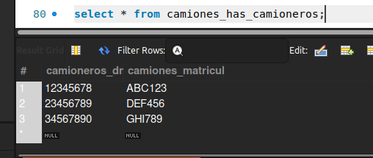
  - UPDATE:
update camiones set matricula="JKL101" where matricula="ABC123";